CA2 Individual Report
Name | Chay Ying En
Student Id | P2523624
Class | DIT/FT/1B/07
Github Repository URL | https://github.com/ST0503-BED/bed-ca2-yingearnn
Github Account ID | yingearnn

For each competencies, find links to pull requests/commits/files that demonstrate the completion of the requirement. Replace each “?” with your Self Rating.
For Self Rating, you may rate yourself accordingly if you feel that you:
- Have little or no understanding. and did not attempt the requirement
- Have limited understanding of the specific competency
- Have basic understanding and only able to replicate examples from tutorials/practicals.
- Have adequate understanding and can extend from what you have learned to fulfil specifications.
- Have solid understanding in the specific competency, able work on the requirement without much references.
- Have excellent understanding and implemented the requirement according to latest industry guidelines, best practices and documentations.

Important
- You are require to provide for each competency:
  - A brief description
  - One or two of your best implementations with URL link to respective repository request/commits/files.
    - Below is an example of linking to specific script file
https://github.com/expressjs/express/blob/master/examples/static-files/index.js
  - The implementations may come from Section A or B.
- You are to ensure the hyperlink in this document works. Failure to do so will result in a 50% deduction of marks.
- You are to provide screenshots using POSTMAN to perform API test.

No. | Competencies | Describe What Was Done | Self Rating
1 | Backend Server | It ensures data sent from the frontend are correct, and checks properly and return appropriate messages.  https://github.com/ST0503-BED/bed-ca2-yingearnn/blob/main/src/controllers/challengesController.js | 3/5
2 | Functionality | Everything works as intended | 5/5
3 | Code Quality | I made common files so it does not need to be repeated in ever file  https://github.com/ST0503-BED/bed-ca2-yingearnn/blob/main/frontend/js/auth.js | 3/5
4 | Modularity | I tried to make repeated functions into a single file to export.  https://github.com/ST0503-BED/bed-ca2-yingearnn/blob/main/frontend/js/notifications.js | 3/5
5 | Error Handling | I include any possible checking for errors into the backend.  https://github.com/ST0503-BED/bed-ca2-yingearnn/blob/main/src/controllers/gardenController.js | 4/5
6 | Documentation | The structure, the endpoints, what features are there  https://github.com/ST0503-BED/bed-ca2-yingearnn/blob/main/README.md | 3/5
7 | JWT for Authentication | I ensured the userID comes from res,locals and to ensure longer duration i edit in the .env  https://github.com/ST0503-BED/bed-ca2-yingearnn/blob/main/src/controllers/userController.js | 3/5
8 | BCrypt for Password Hashing | Passwords are hashed with bcrypt before storing and verified with bcrypt.compare() during login.  I used moderate salt rounds for security without slowing the server, and JWT tokens for efficient authentication after login.  https://github.com/ST0503-BED/bed-ca2-yingearnn/blob/main/src/middlewares/bcryptMiddleware.js | 3/5
9 | Frontend to Backend HTTP Requests | I used the fetch method and fetch from the relative endpoints  https://github.com/ST0503-BED/bed-ca2-yingearnn/blob/main/frontend/js/challenges.js | 3/5
10 | HTML & CSS Proficiency | https://github.com/ST0503-BED/bed-ca2-yingearnn/blob/main/frontend/css/homepage.css | ?/5
12 | JavaScript and DOM Manipulation | The frontend dynamically fetches data from the backend using JavaScript and updates the UI by manipulating the DOM, such as rendering lists of challenges, inventory items, and garden plots in real time. It also uses event listeners to handle user actions like planting, completing challenges, and switching tabs without reloading the page.  https://github.com/ST0503-BED/bed-ca2-yingearnn/blob/main/frontend/js/shop.js | ?/5

Updated Entity Relationship Diagram
ERD
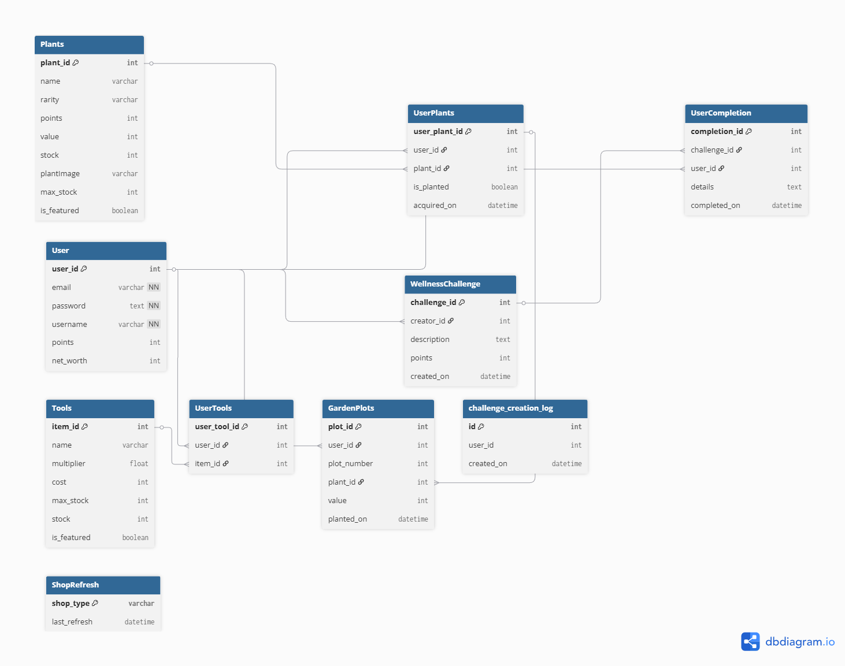

Video Demo
https://youtu.be/hTdJggaUmp0?si=ZIulHiRpWnmuBaRd

